**PDF To Excel Conversion**

**Need to install below Dependency:**

**1] Python version 3.7.3:** <https://drive.google.com/uc?id=1Hwb5RCt_aAS8nawT_CV2k2ZCeRTyVbKo&export=download>

**2] Ghostscript version 9.27:** <https://drive.google.com/uc?id=1vCj4aklJ38CcwCSbA9ZMIpsvHZ_awbyA&export=download>

After Installing ghostscript, set environment Variable ‘Path’ [“C:\Program Files\gs\gs9.27\bin”].

**3] excalibur-py version 0.4.2:** Open CMD and hit command **“pip install excalibur-py”**

This document explain you how Zap Automation will convert PDF file into excel file.

**Step 1:** User can select any pdf file. In this example we have selected following pdf file.

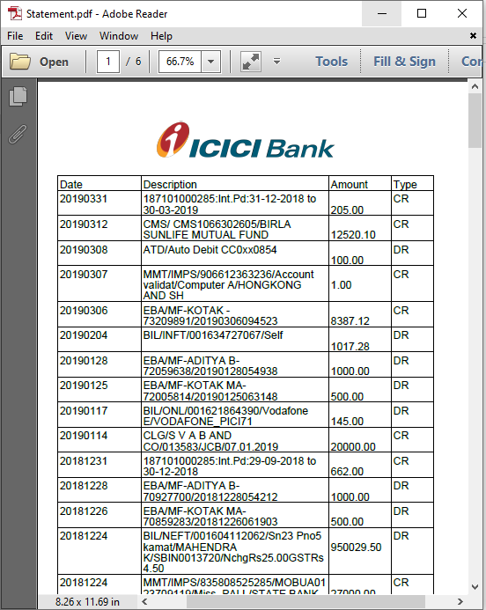

**Step 2:**Right click on **Zap** icon at bottom right corner of your window and select **Task Editor**.

**Step 3:** Drag and Drop **two** **Select File, Pdf Table Extraction using Python** and two **Message Box** action From Activity panel.

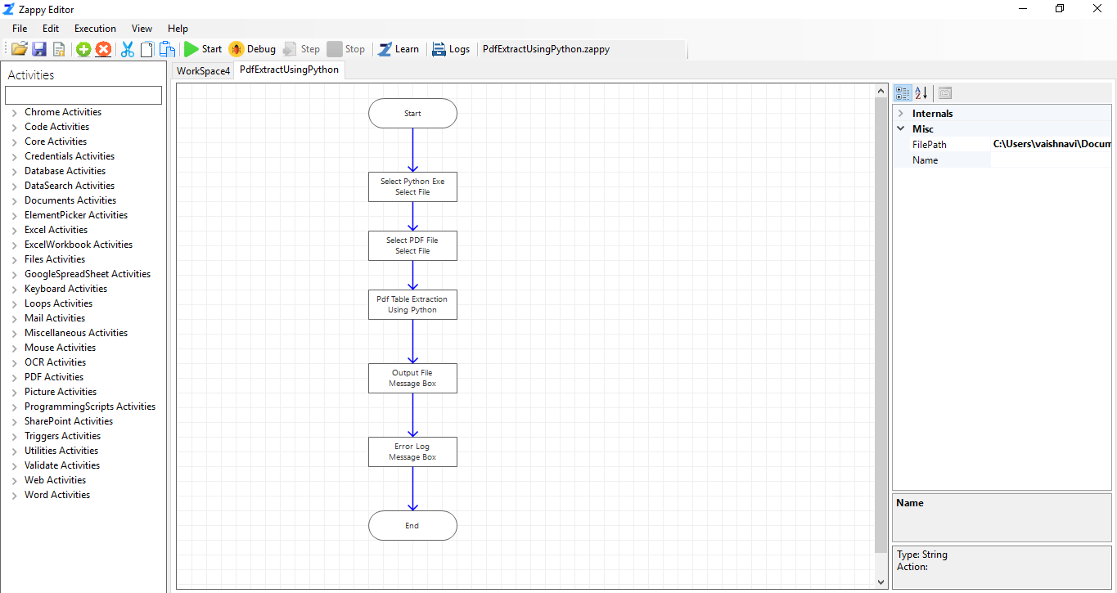

**Step 4:** Click on **Pdf Table extraction using python** and set the properties.

Click on  in front of **InputFilePath** and Select **File Path** of **Select File** action’s output and **OK**.

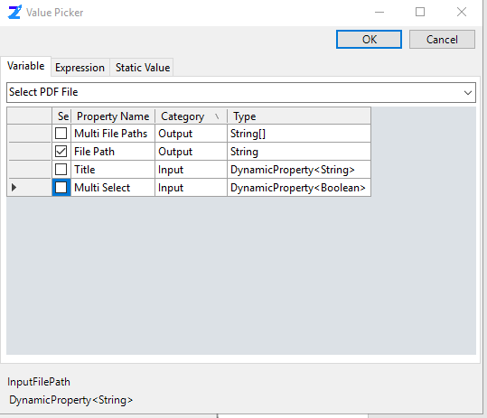

We have to select PDF File type by two ways.

**File Type property** **–** Pdf File Type like lattice or stream.

* **Lattice**: For tables formed with lines.
* **Stream:** For tables formed with whitespaces.

**Step 5:** Click on first **Message Box** and set the Properties. This message box for getting the message of Excel file path.

Click on second **Message Box** and set the Properties. This message box for getting the Error Message.

**Step 6:** Click on **Save**.

**Execution**: To Start the Execution we have to click on start .

Select the python Exe file and click on Open. [Find Python Exe path here **“C:\Users\vaishnavi\AppData\Local\Programs\Python\Python37”]**

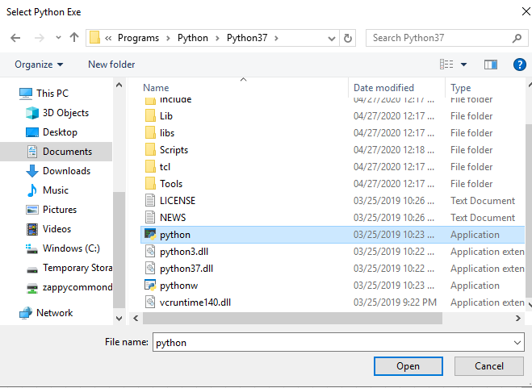

Select PDF File

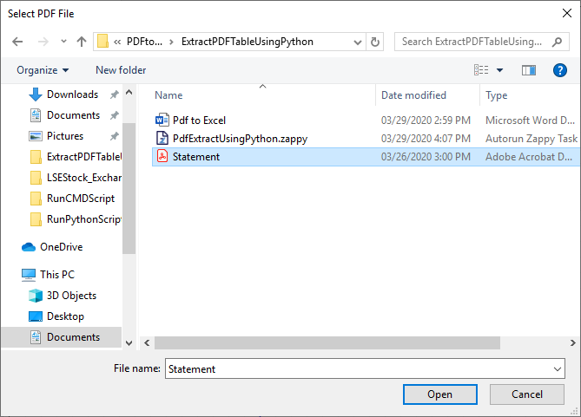

**Output:** Excel file will be crate in same folder as of pdf.

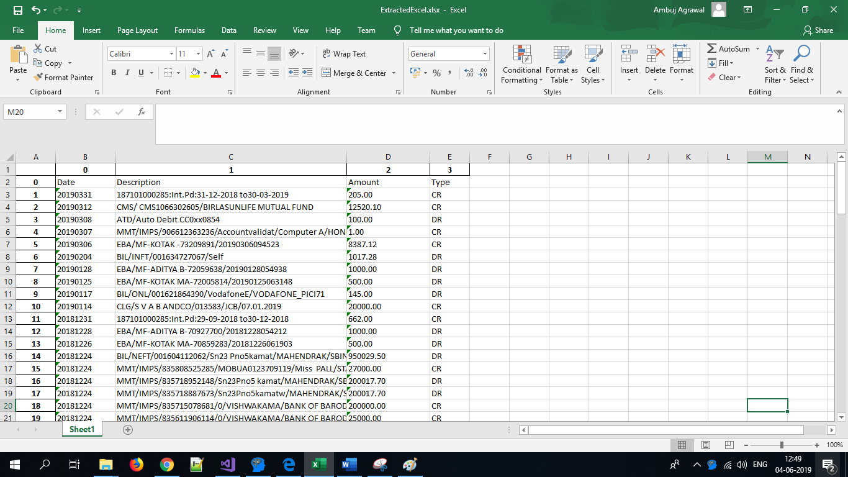

**In this way we can use this auotmation to convert any PDF file into Excel file.**

**Note:** When Zap file is running the Zap symbol on Task bar look like the following (Green Circle)

